Name: ________________________________ Date: ___________________________________

Class: _________________________________ Teacher: ___________________________________

# Math Mini Quiz 1

This Mini Quiz, we’re going to explore the math concepts that you’ve learned so far in this unit. This assignment should take you about **15 minutes**.

### Part 1 Freediving

Free diving is a sport where divers go under the water without the aid of an oxygen tank, like would be the case with scuba diving. To do this, freedivers have to hold their breaths for long periods of time with some of the longest free dives ever lasting over four minutes! Below is a list of numbers representing the highest **number of minutes** dived by the top freedivers.

3.6, 3.0, 3.1, 3.5, 4.5, 2.25, 2.1, 2.0, 1.3

1) Find the **average** of these top freediving times.

2) Find the **median** of these top freediving times.

3) Which of these two would you prefer to use *to describe the center* of this data? Why?

*(yes, there’s a back, don’t forget it)*

### Part 2 Graph Analysis

Below are the histograms of the distance thrown by two different javelin throwers.

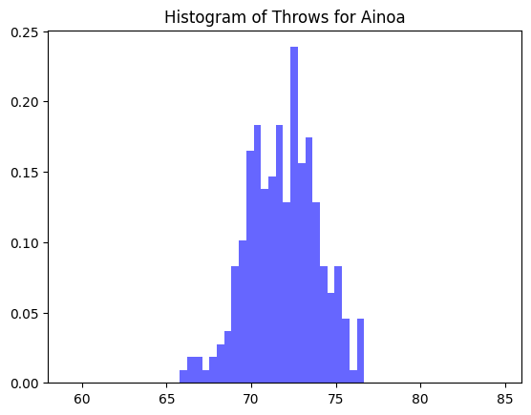 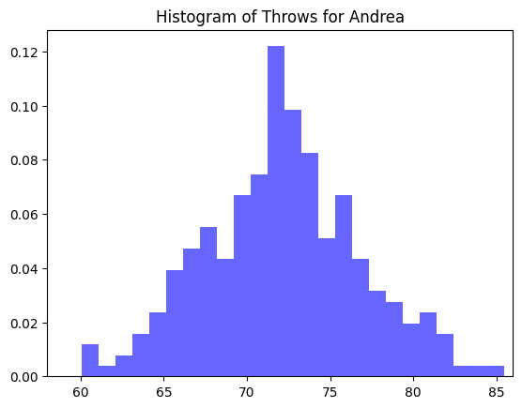

4) Which of these two has the greater standard deviation? What does that tell you about the way that person throws?

Below is a box and whisker plot of the 100m times for a highschool track team.

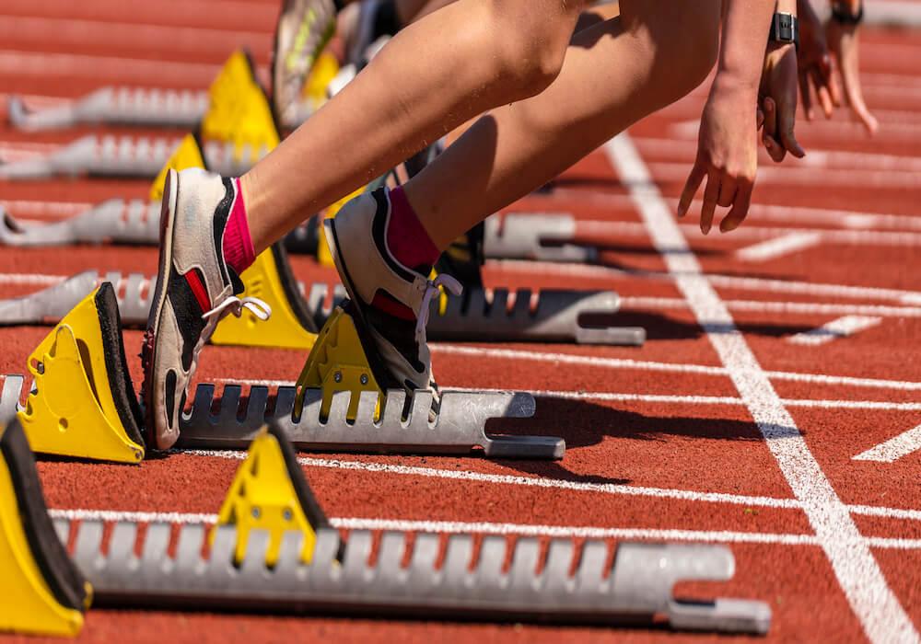

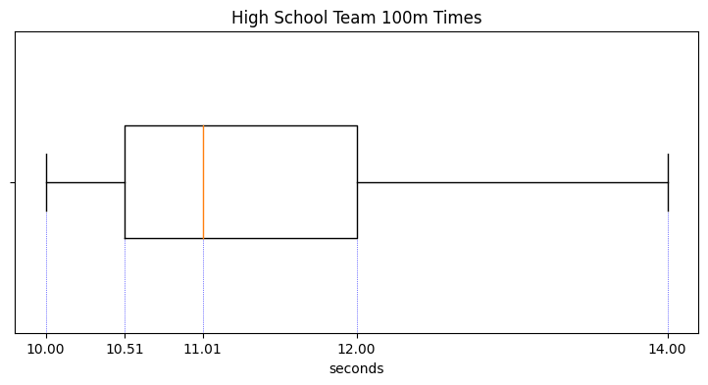

5) Can we find the mean, median, or both from this plot? How do you know? What is it/what are they?

6) Name two ranges in which 75% of the data lies

*The end, good job :)*